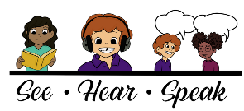
Contact information:
Tiffany P. Hogan, PhD, CCC-SLP
Email: thogan@mghihp.edu
Twitter: @tiffanyphogan
Web: http://www.mghihp.edu/sail-lab/
Facebook: sailliteracylab
Podcast: seehearspeakpodcast.com
DLD information: dldandme.org

The Simple View of Reading (Hoover & Gough, 1990)
Reading Comprehension
Word Recognition
Listening Comprehension

The Language Basis of
Poor Reader Subgroups (Hogan, 2018)
Dyslexia

Poor Reader Subgroups (Adlof & Hogan, 2018)
Dyslexia

Dyslexia + DLD
Word Recognition
Listening Comprehension
Good
Poor
Good
Poor
DLD
DLD

Typical Readers
The Language Basis of
Reading Comprehension (Hogan et al., 2011)
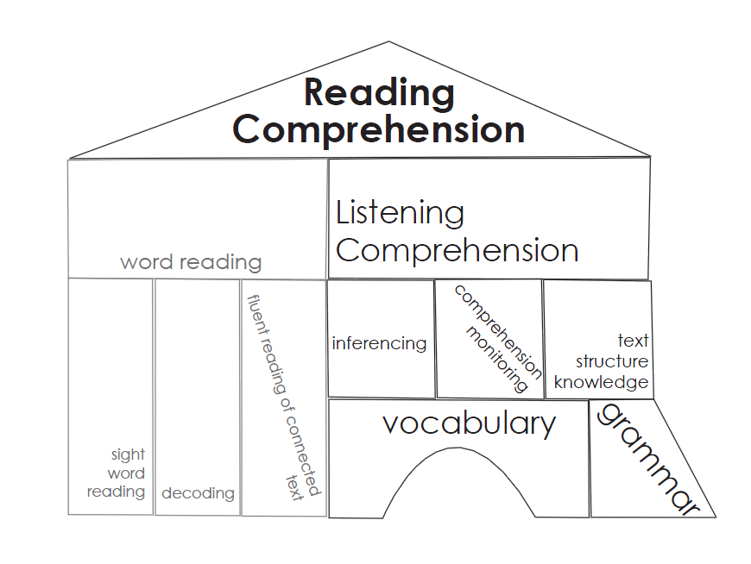

Facts About Developmental Language Disorder (DLD) (McGregor, 2020)
-A person is born with DLD, persists across the lifetime
-Cuts across SES and other disorders
-Brain difference
-Key deficits in vocabulary and grammar learning & use
-50% can read well; so they read words but fail to understand the text, especially struggle with shift from ‘learning to read’ to ‘reading to learn’
-Often ‘missed’ because it’s a ‘hidden’ deficit
-Only ~50% identified in the early grades
-Diagnosed by SLP if language skills lower than peers
-Risk can be identified early and remediation improves reading
-Public awareness is low…working to change that (dldandme.org; radld.org)
-books on DLD: https://www.dldandme.co.uk/the-book;
https://www.routledge.com/Supporting-Children-with-DLD/book-series/SCWDLD

Simple View of Reading & Poor Reader Subgroups (Dyslexia and DLD)
On the Importance of Listening Comprehension: https://www.ncbi.nlm.nih.gov/pmc/articles/PMC4681499/
Dr. Hollis Scarborough ‘The Reading Rope’: https://www.youtube.com/watch?v=83tfzOFpBak&feature=youtu.be
Facts about Dyslexia: www.dyslexiaida.org
An Ounce of Prevention is Worth a Pound of Diagnosis (Dyslexia; Catts & Hogan, 2020): https://psyarxiv.com/nvgje
Facts about DLD: www.dldandme.org www.radld.org
DLD 1-2-3 Video: https://www.youtube.com/watch?v=tQ-s02HWLb0
DLD – A student’s perspective: https://www.youtube.com/watch?time_continue=1&v=KrOISXtCgVA
What’s it’s like to have DLD: https://vimeo.com/361471019
A parent’s perspective on DLD: https://www.youtube.com/watch?v=3MKUgQUhDPM
Myths about DLD: https://dldandme.org/myths-about-dld/)
Information on Specific Language Impairment: https://cldp.ku.edu/sites/cldp.ku.edu/files/docs/OpenAccessE-BookOctober2018.pdf
Understanding Dyslexia in the Context of DLD: https://www.ncbi.nlm.nih.gov/pubmed/30458538
The many names used for DLD: https://dldandme.org/terminology/
Facts about DLD in 20 languages: https://radld.org/about/dld/dld-fact-sheet/

Call to Action
Talking DLD podcast with Dr. Hogan: https://thedldproject.com/language-screening-and-early-identification-of-dld/
SeeHearSpeakPodcast: www.seehearspeakpodcast.com
Dr. Hogan on HarvardEd podcast discussing DLD: https://www.gse.harvard.edu/news/19/12/harvard-edcast-bringing-hidden-language-disorder-light
Measuring Language Development to Inform Literacy Instruction: https://journals.sagepub.com/doi/full/10.1177/2372732219839075
Google doc of language screeners: https://tinyurl.com/screen4DLD
Tools chart to evaluate screening tests (& progress monitoring tools and interventions):
https://charts.intensiveintervention.org/chart/academic-screening
CUBED free assessment of word reading, listening comprehension, and reading comprehension:
https://www.languagedynamicsgroup.com/products/cubed/cubed_download/
Dyslexia: An ounce of prevention is worth a pound of diagnosis: https://psyarxiv.com/nvgje/
A call for school-based language screenings: https://dldandme.org/school-language-screening/
Preschool language precursors to later reading problems: http://www.onlinedigeditions.com/publication/?m=13959&i=671218&p=37&pp=1&ver=html5
DLD Diagnostics Toolbox: https://www.uwo.ca/fhs/lwm/news/2020/06_24_BlogIntroduction.html
Teachers supporting children with DLD: https://dldandme.org/supporting-a-child-with-dld-in-the-classroom/
Florida Center for Reading Research reading at home resources: https://fcrr.org/resources/home-learning

Comprehension Instruction
Reading for Understanding: https://ies.ed.gov/pdf/RFU_Nov2016.pdf
Comprehension Lessons for Pre-K to Grade 3: https://larrc.ehe.osu.edu/
Comprehension Lessons for Middle Schoolers:
https://www.meadowscenter.org/library/resource/pact-plus-sample-lessons
https://www.serpinstitute.org/adolescent-literacy
Trina’s Toolbox: http://www.trinastoolbox.com/
Increasing language skills to improve reading comprehension: https://digitalcommons.unl.edu/cgi/viewcontent.cgi?article=1079&context=specedfacpub
Bringing words to life, second edition: https://www.amazon.com/Bringing-Words-Life-Second-Instruction/dp/1462508162
www.booksharetime.com; https://mayasbooknook.com/
Foundational skills to support reading for understanding: https://nces.ed.gov/pubsearch/pubsinfo.asp?pubid=WWCPGLit21

